AIASSISTEDCODING ASSIGNMENT - 20.1

ROLL NO. 2303A51967

Task1–InputValidationCheck Task:
AnalyzeanAI-generatedPythonloginscriptforinputvalidation vulnerabilities.
Instructions:
- PromptAItogenerateasimpleusername-password login program.
- Reviewwhetherinputsanitizationandvalidationare implemented.
- Suggestsecureimprovements(e.g.,usingreforinput validation).
ExpectedOutput:
- Asecureversionoftheloginscriptwithproperinput Validation.

Prompt:
Generate a simple Python username-password login program. Do not include any input validation or sanitization.Ionlyneedabasicloginflowwithastored username and password.

Code:
stored_username = "user123"
stored_password = "pass456"

username=input("Enterusername:") password = input("Enter password: ")

ifusername == stored_username and password == stored_password:

print("Login successful!")
elifusername==stored_usernameandpassword!=stored_password: print("Incorrect password.")
elifusername!=stored_username: print("Incorrect username.")
else:
print("Login failed.")

Output:
Enterusername:user123 Enterpassword:pass456 Login successful!

Reviewprompt:
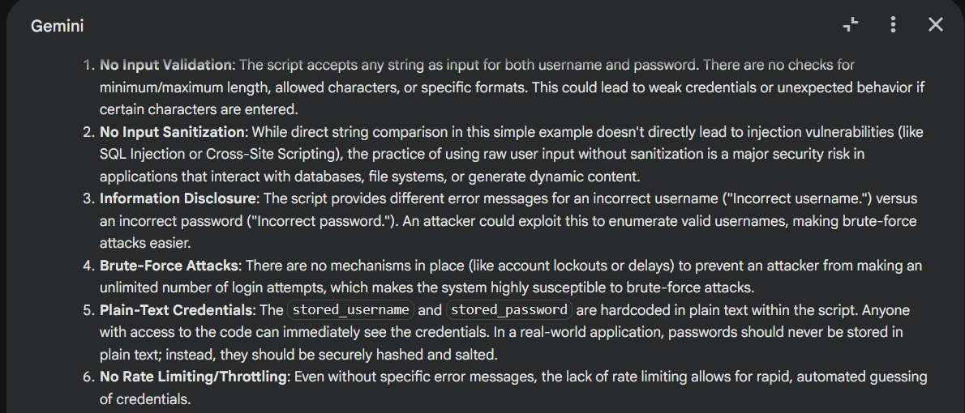
AnalyzethePythonloginscriptyougenerated.Identifyifinput validation or sanitization is missing. Point out all security vulnerabilities related to raw user input.

Secureversionprompt:
Rewritetheloginscriptwithproperinputvalidation.Ensure:

- usernameandpasswordaresanitized
- onlyallowedcharactersareaccepted(useregex)
- preventblankinputs
- addclearerrorhandling
ProvidethefinalsecurePythonscript.

Code:
import re

stored_username = "user123"
stored_password="pass456"#Inarealapplication,passwordsshouldbe securely hashed and salted, not stored in plain text!

# Regex for allowed characters
# Username: alphanumeric, underscore, hyphen USERNAME_PATTERN=re.compile(r"^[a-zA-Z0-9_-]+$")
#Password:alphanumericandcommonspecialcharacters PASSWORD_PATTERN =
re.compile(r"^[a-zA-Z0-9!@#$%^&*()_+=\-\{\}\[\]:;\"'<,>.?/|`~]+$")

#Inputloopforusernamewithvalidation while True:
username=input("Enterusername:").strip()#.strip()removes leading/trailing whitespace
if not username:
print("Usernamecannotbeblank.Pleasetryagain.") elif not USERNAME_PATTERN.match(username):
print("Invalidusername.Onlyalphanumericcharacters, underscores, and hyphens are allowed. Please try again.")
else:
break # Valid username entered

#Inputloopforpasswordwithvalidation while True:
password=input("Enterpassword:").strip() if not password:
print("Password cannot be blank. Please try again.")

elifnot PASSWORD_PATTERN.match(password):
print("Invalidpassword.Pleaseusealphanumericcharactersand common symbols. Please try again.")
else:
break # Valid password entered

#Loginlogicwithgenericerrormessagetopreventusernameenumeration if username == stored_username and password == stored_password:
print("Loginsuccessful!") else:
print("Invalid username or password.") # Generic message for security

Output:
Enterusername:user123 Enterpassword:pass456 Login successful!

Task2–SQLInjectionPrevention Task:
TestanAI-generatedscriptthatperformsSQLqueriesona database.
Instructions:
- AskAItogenerateaPythonscriptusingSQLite/MySQLto fetch user details.
- IdentifyifthecodeisvulnerabletoSQLinjection(e.g., using string concatenation in queries).
- Refactorusingparameterizedqueries(prepared statements).
ExpectedOutput:
- AsecuredatabasequeryscriptresistanttoSQL injection.

Prompt:
Generate a Python script using SQLite (or MySQL) that fetches user details based on a username. Do not use parameterizedqueries;usesimplestringconcatenationfor the SQL query. Keep it short and functional.

Code:
import sqlite3

#---DatabaseSetup(fordemonstration)--- conn = sqlite3.connect('users.db')
cursor = conn.cursor()

#Createtableifitdoesn'texist cursor.execute('''
CREATETABLEIFNOTEXISTSusers( id INTEGER PRIMARY KEY,
usernameTEXTNOTNULLUNIQUE, email TEXT NOT NULL,
password_hash TEXT NOT NULL
) ''')

#Insertsomesampledata(onlyiftableisempty) cursor.execute("SELECT COUNT(*) FROM users")
if cursor.fetchone()[0] == 0:
cursor.execute("INSERTINTOusers(username,email,password_hash) VALUES ('alice', 'alice@example.com','hash1')")
cursor.execute("INSERTINTOusers(username,email,password_hash) VALUES ('bob', 'bob@example.com','hash2')")
conn.commit()
print("Database'users.db'isreadywithsampledata.") # --- User Input and INSECURE Query ---

search_username=input("Enterusernametofetchdetails(e.g.,'alice'): ")

#!!!WARNING:THISISHIGHLYINSECUREANDVULNERABLETOSQLINJECTION!!! # DO NOT USE THIS IN PRODUCTION CODE.
sql_query="SELECTid,username,emailFROMusersWHEREusername='"+ search_username + "'"

print(f"\nExecutingINSECURE SQL query: {sql_query}")

try:
cursor.execute(sql_query) user_details=cursor.fetchone()

if user_details: print("\nUserFound:")
print(f"ID: {user_details[0]}") print(f"Username:{user_details[1]}") print(f"Email: {user_details[2]}")
else:
print("\nUsernotfound.") except sqlite3.Error as e:
print(f"\nAnerroroccurredduringqueryexecution:{e}") finally:
conn.close() print("\nConnectionclosed.")

Output:
Database 'users.db' is ready with sample data. Enterusernametofetchdetails(e.g.,'alice'): alice

Executing INSECURE SQL query: SELECT id, username,emailFROMusersWHEREusername= 'alice'

UserFound:
ID:1
Username:alice
Email:alice@example.com

Connectionclosed.

Refactoredprompt:
Analyzethedatabasescriptyougenerated.IdentifyallSQL injection vulnerabilities, especially where user input is concatenated directly into SQL queries. Explain why it is insecure.

Code:
import sqlite3

#---DatabaseSetup(fordemonstration)--- conn = sqlite3.connect('users.db')
cursor = conn.cursor()

#Createtableifitdoesn'texist cursor.execute('''
CREATETABLEIFNOTEXISTSusers( id INTEGER PRIMARY KEY,
usernameTEXTNOTNULLUNIQUE, email TEXT NOT NULL,
password_hash TEXT NOT NULL
) ''')

#Insertsomesampledata(onlyiftableisempty) cursor.execute("SELECT COUNT(*) FROM users")

if cursor.fetchone()[0] == 0:
cursor.execute("INSERTINTOusers(username,email,password_hash) VALUES ('alice', 'alice@example.com','hash1')")
cursor.execute("INSERTINTOusers(username,email,password_hash) VALUES ('bob', 'bob@example.com','hash2')")
conn.commit()
print("Database'users.db'isreadywithsampledata.") # --- User Input and SECURE Query ---
search_username=input("Enterusernametofetchdetails(e.g.,'alice'): ")

#Thisisthesecurewaytoqueryadatabaseusingparameterizedqueries. # The '?' is a placeholder for the parameter.
sql_query = "SELECT id, username, email FROM users WHERE username = ?"

print(f"\nExecutingSECURESQLquery:{sql_query}withparameter '{search_username}'")

try:
#Passtheparameterasatupletotheexecutemethod cursor.execute(sql_query, (search_username,)) user_details = cursor.fetchone()

if user_details: print("\nUserFound:")
print(f"ID: {user_details[0]}") print(f"Username:{user_details[1]}") print(f"Email: {user_details[2]}")
else:
print("\nUsernotfound.") except sqlite3.Error as e:
print(f"\nAnerroroccurredduringqueryexecution:{e}") finally:
conn.close() print("\nConnectionclosed.")

Output:

Database 'users.db' is ready with sample data. Enterusernametofetchdetails(e.g.,'alice'): alice

ExecutingSECURESQLquery:SELECTid,username, email FROM users WHERE username = ? with parameter 'alice'

UserFound:
ID:1
Username:alice
Email:alice@example.com

Connectionclosed.

Task3–Cross-SiteScripting(XSS)Check Task:
EvaluateanAI-generatedHTMLformwithJavaScriptforXSS vulnerabilities.
Instructions:
- AskAItogenerateafeedbackformwithJavaScript-based output.
- Testwhetheruntrustedinputsaredirectlyrendered without escaping.
- Implementsecuremeasures(e.g.,escapingHTML entities, using CSP).

ExpectedOutput:
- AsecureformthatpreventsXSSattacks. Prompt:
GenerateasimpleHTMLfeedbackformwithJavaScriptthat displays the user’s input on the page. Do not escape or sanitize the input. Just a basic form and script that prints the input directly.

Code:
%%html
<style>
body { font-family: sans-serif; margin: 20px; }
.container { max-width: 600px; margin: auto; padding: 20px; border: 1pxsolid#ccc;border-radius:8px;box-shadow:02px4pxrgba(0,0,0,0.1);
}
label { display: block; margin-bottom: 8px; font-weight: bold; } textarea{width:100%;padding:10px;margin-bottom:15px;border:
1pxsolid#ddd;border-radius:4px;box-sizing:border-box;resize: vertical; min-height: 100px; }
button{background-color:#007bff;color:white;padding:10px15px; border: none; border-radius: 4px; cursor: pointer; font-size: 16px; }
button:hover { background-color: #0056b3; }
#output{margin-top:20px;padding:15px;background-color:#f8f9fa; border: 1px solid #e9ecef; border-radius: 4px; white-space: pre-wrap; word-break: break-all; }
h2 { color: #333; }
</style>
<div class="container">
<h2>Feedback Form</h2>
<form id="feedbackForm">
<labelfor="feedbackInput">Your Feedback:</label>
<textareaid="feedbackInput"placeholder="Typeyourfeedback here..."></textarea>
<buttontype="submit">Submit Feedback</button>
</form>

<h3>Your Input:</h3>
<divstyle="background-color: black"id="output"></div>
</div>

<script>
document.getElementById('feedbackForm').addEventListener('submit', function(event) {
event.preventDefault(); // Prevent default form submission constinput=document.getElementById('feedbackInput').value; const outputDiv = document.getElementById('output');
// Display the raw input directly without escaping or sanitizing outputDiv.innerHTML=input;//UsinginnerHTMLtoshowrawinput
including any HTML tags
});
</script>

Output:
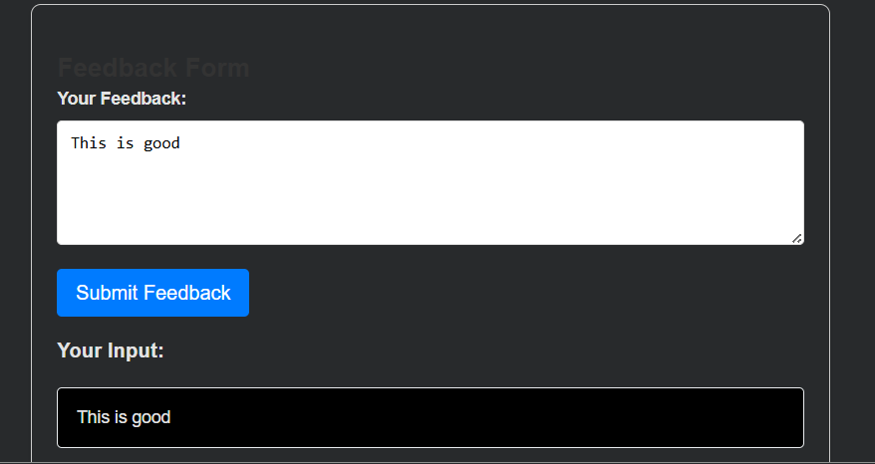

Reviewprompt:
AnalyzetheHTML/JavaScriptcodeyougenerated.Identifyall XSS vulnerabilities, especially any place where user input is

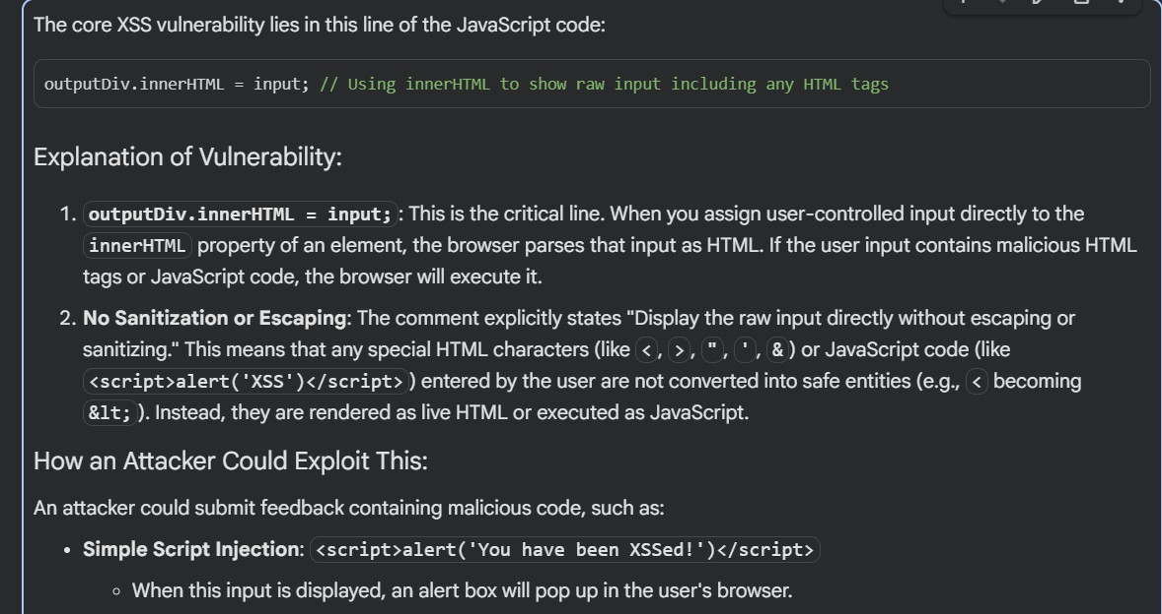
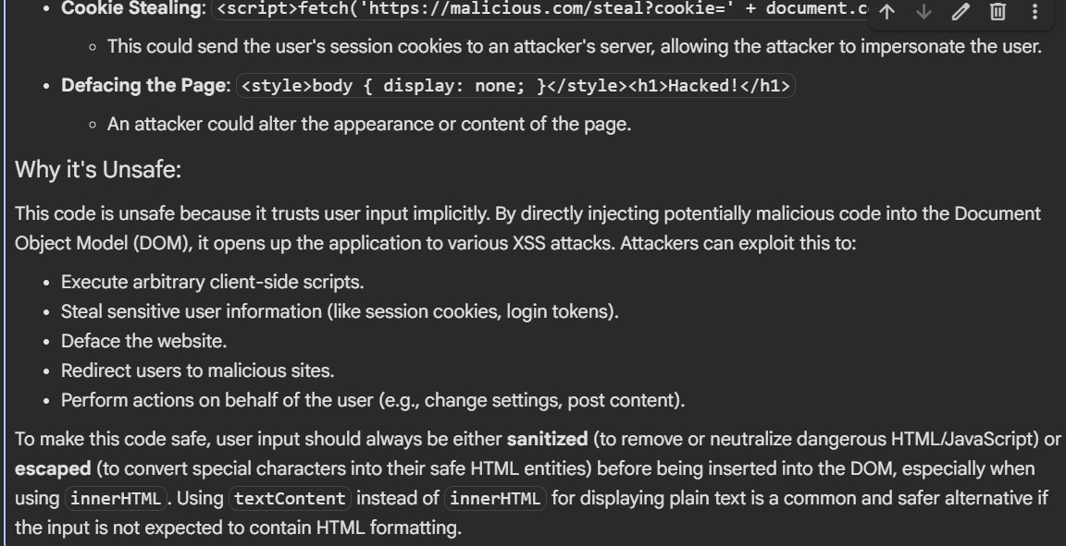
insertedintotheDOMwithoutsanitizationorescaping. Explain why the code is unsafe.

Secureprompt:
Rewritethefeedbackformsecurely.Implement:

- properescapingofHTMLentitiesbeforedisplayinguser input
- preventionofscriptexecution
- safeDOMinsertion(e.g.,textContentinsteadofinnerHTML) Also suggest optional improvements like using a Content Security Policy (CSP).
ProvidethefinalsecureHTML/JScode.

Code:
%%html
<style>
body { font-family: sans-serif; margin: 20px; }
.container { max-width: 600px; margin: auto; padding: 20px; border: 1pxsolid#ccc;border-radius:8px;box-shadow:02px4pxrgba(0,0,0,0.1);
}
label { display: block; margin-bottom: 8px; font-weight: bold; } textarea{width:100%;padding:10px;margin-bottom:15px;border:
1pxsolid#ddd;border-radius:4px;box-sizing:border-box;resize: vertical; min-height: 100px; }
button{background-color:#28a745;color:white;padding:10px15px; border: none; border-radius: 4px; cursor: pointer; font-size: 16px; }
button:hover { background-color: #218838; }
#output{margin-top:20px;padding:15px;background-color:#e9f7ef; border: 1px solid #c3e6cb; border-radius: 4px; white-space: pre-wrap; word-break: break-all; color: #155724; }
h2 { color: #333; }
</style>
<div class="container">
<h2>Secure Feedback Form</h2>
<form id="feedbackForm">
<labelfor="feedbackInput">Your Feedback:</label>
<textareaid="feedbackInput"placeholder="Typeyourfeedback here..."></textarea>
<buttontype="submit">Submit Feedback</button>
</form>

<h3>Your Input (Securely Displayed):</h3>
<div id="output"></div>
</div>

<script>
document.getElementById('feedbackForm').addEventListener('submit', function(event) {
event.preventDefault(); // Prevent default form submission constinput=document.getElementById('feedbackInput').value; const outputDiv = document.getElementById('output');

// --- SECURE DOM INSERTION ---
// Using textContent instead of innerHTML to prevent XSS.
// textContent automatically escapes HTML entities,
//treatingtheinputasplaintext,notexecutableHTML. outputDiv.textContent = input;
});
</script>

Output:
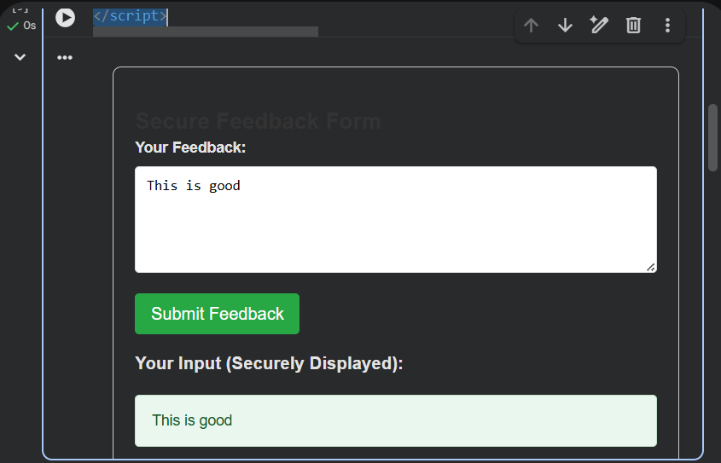

Task4–Real-TimeApplication:SecurityAuditofAI- Generated Code
Scenario:
StudentspickanAI-generatedprojectsnippet(e.g.,login form,
APIintegration,orfileupload). Instructions:
- Performasecurityaudittodetectpossible vulnerabilities.
- PromptAItosuggestsecurecodingpracticestofix issues.
- Compareinsecurevssecureversionssidebyside. Expected Output:
- Asecurity-auditedcodesnippetwithdocumented vulnerabilities and fixes.

Prompt:
Generate an insecure code snippet for a small application featureonloginform.Donotapplyanysecuritymeasures.I need intentionally vulnerable code for auditing.

Insecurecode:
%%html
<style>
body{font-family:sans-serif;margin:20px;background-color: #f8f9fa; color: #333; }

.container { max-width: 400px; margin: auto; padding: 30px; border: 1pxsolid#dc3545;border-radius:8px;background-color:#fff;box-shadow:
0 4px 8px rgba(0,0,0,0.1); }
h2 { color: #dc3545; text-align: center; margin-bottom: 25px; } label { display: block; margin-bottom: 8px; font-weight: bold; } input[type="text"],input[type="password"]{width:100%;padding:
10px;border:1pxsolid#ced4da;border-radius:5px;margin-bottom:15px; box-sizing: border-box; }
button { background-color: #dc3545; color: white; padding: 12px 20px; border:none;border-radius:5px;cursor:pointer;font-size:16px;width: 100%; }
button:hover { background-color: #c82333; }
.warning{color:#dc3545;background-color:#f8d7da;border:1px solid #f5c6cb; padding: 10px; border-radius: 5px; margin-top: 20px; font-weight: bold; text-align: center; }
</style>
<div class="container">
<h2>Insecure Login Form</h2>
<formaction="/login_insecure.php"method="post">
<label for="username">Username:</label>
<inputtype="text"id="username"name="username"placeholder="Enter your username"required>

<label for="password">Password:</label>
<inputtype="password"id="password"name="password"placeholder="Enter your password"required>

<button type="submit">Login</button>
</form>
<div class="warning">
WARNING:ThisloginformisHIGHLYINSECURE.Itdemonstrateshow NOT to handle user authentication.
A real backend for this form would perform no input validation, useplaintextpasswords,andbevulnerabletoSQLinjection,brute-force attacks, and more.
</div>
</div>

Output:

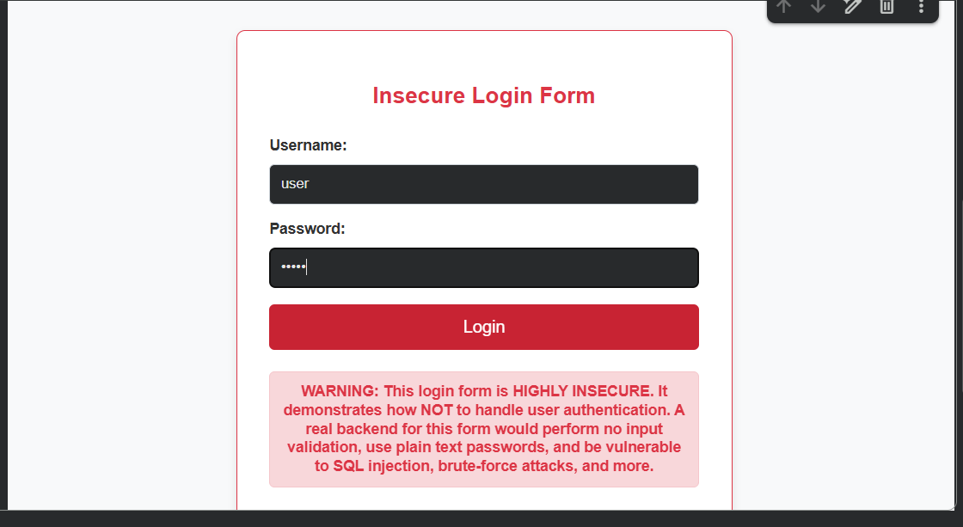

Securityauditprompt:
Performacompletesecurityauditofthecodeyougenerated. Identify vulnerabilities such as:
- inputvalidationissues
- authentication/logicproblems
- insecureAPIusage
- fileuploadvalidationissues
- missingerrorhandling
- missingencryption
Foreachvulnerability,explaintheriskclearly. Output:

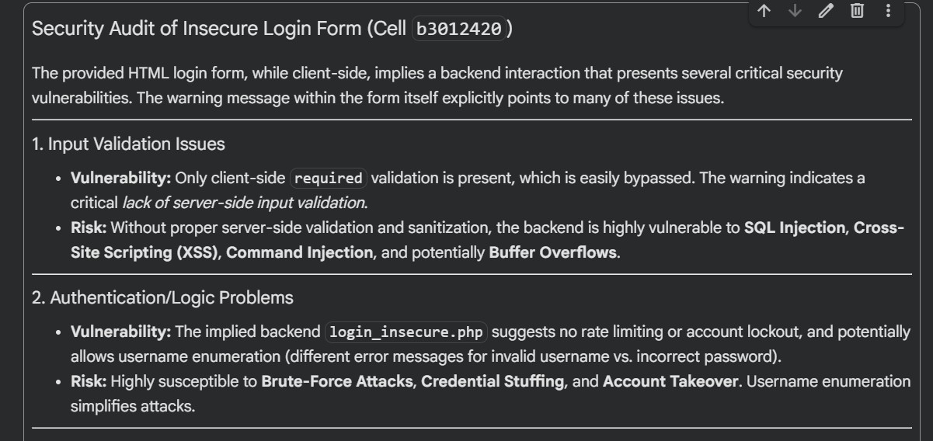
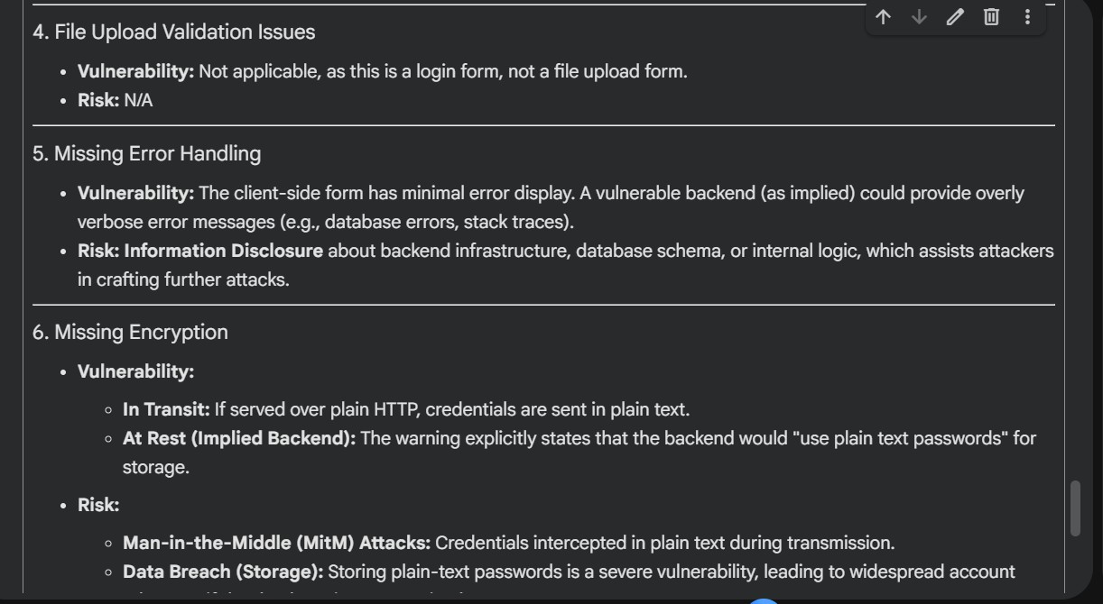

Securecodeprompt:
Basedonthevulnerabilitiesyouidentified,providesecure coding practices to fix them. Include techniques such as sanitization, validation, parameterized queries, safe file handling, proper authentication, and secure API usage.

Code:
%%html
<style>
body{font-family:sans-serif;margin:20px;background-color: #f8f9fa; color: #333; }
.container { max-width: 400px; margin: auto; padding: 30px; border: 1pxsolid#28a745;border-radius:8px;background-color:#fff;box-shadow:
0 4px 8px rgba(0,0,0,0.1); }
h2 { color: #28a745; text-align: center; margin-bottom: 25px; } label { display: block; margin-bottom: 8px; font-weight: bold; } input[type="text"],input[type="password"]{width:100%;padding:
10px;border:1pxsolid#ced4da;border-radius:5px;margin-bottom:15px; box-sizing: border-box; }
button { background-color: #28a745; color: white; padding: 12px 20px; border:none;border-radius:5px;cursor:pointer;font-size:16px;width: 100%; }
button:hover { background-color: #218838; }
</style>
<div class="container">
<h2>Secure Login</h2>
<!--
Theactionpointstoahypotheticalsecurebackendendpoint. This form *must* be served over HTTPS.
-->
<formaction="https://your-secure-backend.com/login"method="post">
<label for="username">Username:</label>
<input type="text"id="username"name="username"placeholder="Enteryourusername"requiredminlength="3"maxlength="50">

<label for="password">Password:</label>
<input type="password"id="password"name="password"placeholder="Enteryourpassword"requiredminlength="8"maxlength="100">

<button type="submit">Login</button>
</form>
<p style="text-align: center; margin-top: 20px;">Don't have an account?<ahref="https://your-secure-backend.com/register">Register here</a></p>

</div>

Output:
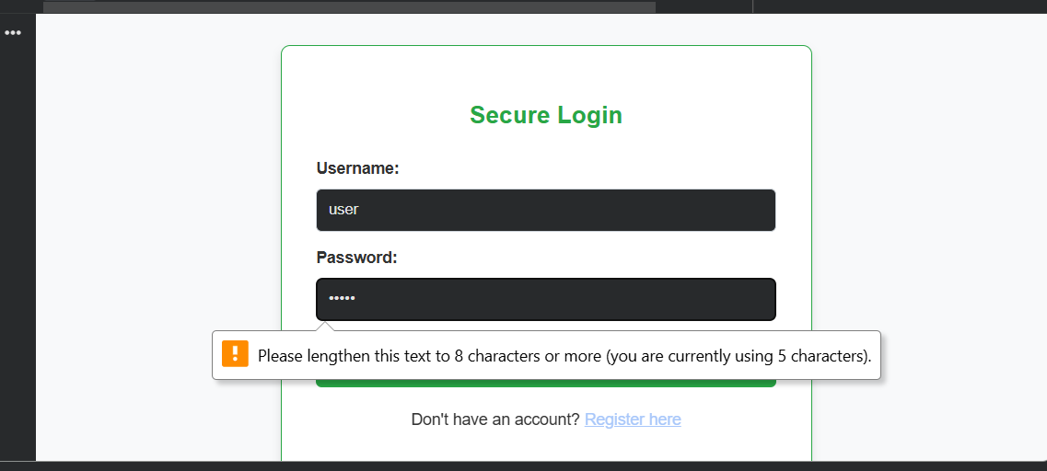

Comparison:

INSECUREVERSION | SECUREVERSION
username=input() | username = sanitize(input())
query="SELECT*  ..." | query = db.execute("SELECT  *...WHEREx=?",  params)
innerHTML= userInput | textContent = sanitizedInput

file.save(upload_pat h) | validatefiletype+restrict extensions + use safe  filenames

Task5–InsecureDataSerializationCheck Task:
EvaluateAI-generatedcodethatusespickleforsavinguser data.
Instructions:
- AskAItogenerateascriptusingpickle.load().
- Explainwhyuntrustedpickledataisdangerous.
- ReplacewithsaferformatslikeJSON. Expected Output:
- SecureserializationcodeusingJSONinsteadofpickle.

Prompt:
Generate a simple Python script that saves and loads user datausingpickle.dump()andpickle.load().Donotincludeany security precautions. I need intentionally insecure code.

Insecurecode:
importpickle import os

defsave_user_data_insecure(username,password, filename='user_data.pickle'):
"""Saves user data using pickle.dump() without any security.

WARNING:Thismethodishighlyinsecureasitstorespasswordsin plaintext
andusespickle,whichcanexecutearbitrarycodeupondeserialization if the file is tampered with.
"""
user_data = {
'username': username,
'password': password #Storingpasswordinplaintext-HIGHLY INSECURE
}
try:
withopen(filename,'wb')asf: pickle.dump(user_data, f)
print(f"Userdatafor'{username}'savedto{filename} (INSECURELY).")
except Exception as e:
print(f"Error saving data: {e}")

def load_user_data_insecure(filename='user_data.pickle'): """Loadsuserdatausingpickle.load()withoutanysecurity.

WARNING:Loadingpickleddatafromanuntrustedsourcecanleadto arbitrarycodeexecution.Thisfunctionisintentionallyinsecure. """
if not os.path.exists(filename): print(f"File'{filename}'notfound.") return None
try:
with open(filename, 'rb') as f:
user_data = pickle.load(f) # Arbitrary code execution
vulnerability
print(f"Userdataloadedfrom{filename}(INSECURELY).") return user_data
except Exception as e:
print(f"Errorloadingdata:{e}") return None

#---Demonstrationofinsecureusage--- # 1. Save some insecure user data

print("\n--- Saving Insecure Data ---") save_user_data_insecure('insecure_user','plaintext_password123')

# 2. Load the insecure user data print("\n---LoadingInsecureData---") loaded_data = load_user_data_insecure()

if loaded_data:
print(f"LoadedUsername:{loaded_data.get('username')}") print(f"LoadedPassword: {loaded_data.get('password')}")

#3.Demonstratepotentialarbitrarycodeexecution(ifmaliciouspickle file was present)
#Forexample,ifamaliciousactorcreatedauser_data.picklefilewith: # import os; class RCE: def reduce(self): return os.system, ('echo PWNED!',);
# pickle.dump(RCE(), open('user_data.pickle', 'wb'))
# Then calling load_user_data_insecure() would execute 'echo PWNED!'

print("\n!!! SECURITY ALERT !!!")
print("Theusageof`pickle`foruntrusteddata serialization/deserialization")
print("andstoringplaintextpasswordsisEXTREMELYDANGEROUSandshould NEVER")
print("bedoneinarealapplication.Thiscodeisfordemonstrationof") print("vulnerabilities only.")

Output:
--- Saving Insecure Data ---
User data for 'insecure_user' saved to user_data.pickle (INSECURELY).

--- Loading Insecure Data ---
Userdataloadedfromuser_data.pickle(INSECURELY). Loaded Username: insecure_user
Loaded Password: plaintext_password123

!!! SECURITY ALERT !!!
The usage of `pickle` for untrusted data serialization/deserialization andstoringplaintextpasswordsisEXTREMELYDANGEROUSandshouldNEVER be done in a real application. This code is for demonstration of

vulnerabilities only.

Explanation:
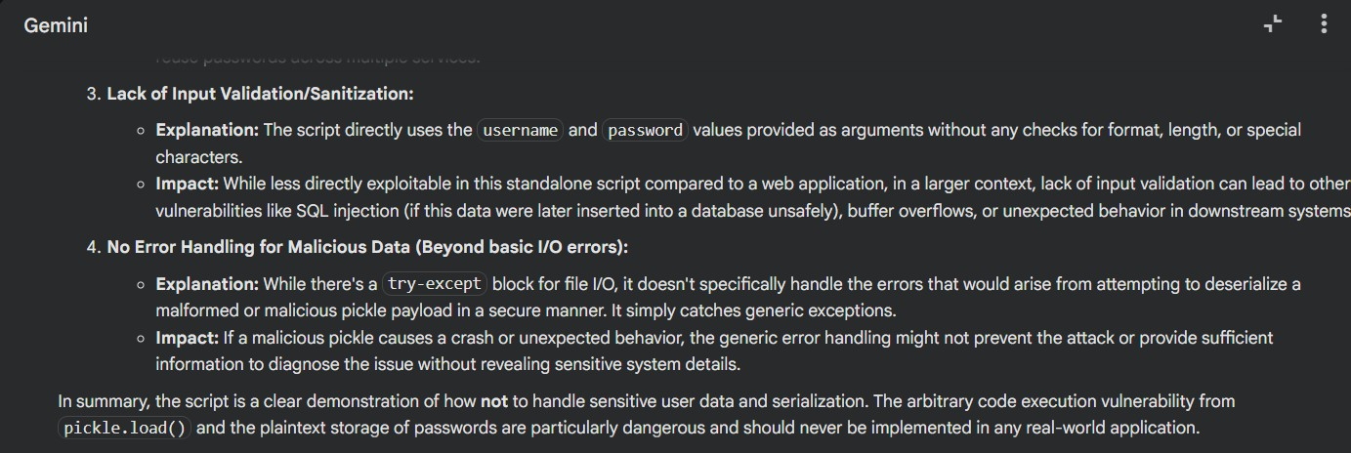

Prompt:
Rewrite the script using JSON for serialization instead of pickle. Ensure the script safely handles user data, validates thestructure,andavoidsexecutingarbitrarycode.Providethe final secure version.

Securecode:
importjson import os
from werkzeug.security import generate_password_hash, check_password_hash

defsave_user_data_secure_json(username,password, filename='secure_user_data.json'):
"""Saves user data securely using JSON, with hashed passwords.

Args:
username (str): The user's username.
password (str): The user's plaintext password. This will be
hashed.
filename (str): The name of the file to save the data to.
"""

# 1. Hash the password securely
password_hash= generate_password_hash(password)

user_data = {
'username': username,
'password_hash':password_hash#Storehashedpassword,not plaintext
}

try:
with open(filename, 'w') as f: json.dump(user_data,f,indent=4)
print(f"Userdata for '{username}' saved to {filename}
(SECURELY).")
except Exception as e:
print(f"Error saving data: {e}")

def load_user_data_secure_json(filename='secure_user_data.json'): """LoadsuserdatasecurelyfromaJSONfileandvalidatesits
structure.

Args:
filename (str): The name of the file to load the data from.

Returns:
dict: The loaded user data if successful and valid, otherwise
None.
"""
if not os.path.exists(filename): print(f"File'{filename}'notfound.") return None

try:
withopen(filename,'r')asf: user_data = json.load(f)

# 2. Validate data structure
ifnotisinstance(user_data,dict)or'username'notinuser_data or 'password_hash'not in user_data:
print(f"Error:Invalid data structure in '{filename}'.")

return None

print(f"Userdataloadedfrom{filename}(SECURELY).") return user_data
except json.JSONDecodeError:
print(f"Error:InvalidJSONformatin'{filename}'.") return None
except Exception as e:
print(f"Errorloadingdata:{e}") return None

defverify_user_password(username_to_check,password_to_check, filename='secure_user_data.json'):
"""Verifies a user's password against the stored hashed password.

Args:
username_to_check (str): The username to verify. password_to_check(str):Theplaintextpasswordtocheck. filename (str): The file containing the user data.

Returns:
bool: True if the username and password match, False otherwise.
"""
user_data= load_user_data_secure_json(filename)
ifuser_dataanduser_data['username']==username_to_check: # 3. Check password hash
returncheck_password_hash(user_data['password_hash'], password_to_check)
return False
#---Demonstrationofsecureusage--- # 1. Save secure user data
print("\n--- Saving Secure Data ---") secure_username = 'secure_user'secure_password='secure_password_123'
save_user_data_secure_json(secure_username,secure_password)

# 2. Load the secure user data print("\n---LoadingSecureData---")

loaded_secure_data = load_user_data_secure_json()

if loaded_secure_data:
print(f"LoadedUsername:{loaded_secure_data.get('username')}") print(f"Loaded Password Hash:
{loaded_secure_data.get('password_hash')[:20]}...") # Show truncated hash

# 3. Verify user password
print("\n--- Verifying User Passwords ---")
ifverify_user_password(secure_username,secure_password): print(f"Password for '{secure_username}' is CORRECT.")
else:
print(f"Passwordfor '{secure_username}' is INCORRECT.")

# Test with an incorrect password
if verify_user_password(secure_username, 'wrong_password'): print(f"Passwordfor'{secure_username}'is(incorrectly)CORRECT.")
else:
print(f"Passwordfor '{secure_username}' is (correctly) INCORRECT.")

print("\nThisrevisedscriptdemonstratesasignificantlymoresecure approach to handling user data.")

Output:

--- Saving Secure Data ---
User data for 'secure_user' saved to secure_user_data.json (SECURELY).

--- Loading Secure Data ---
Userdataloadedfromsecure_user_data.json(SECURELY). Loaded Username: secure_user
Loaded Password Hash: scrypt:32768:8:1$Spb...

--- Verifying User Passwords ---
Userdataloadedfromsecure_user_data.json(SECURELY). Password for 'secure_user' is CORRECT.
Userdataloadedfromsecure_user_data.json(SECURELY). Password for 'secure_user' is (correctly) INCORRECT.

Thisrevisedscriptdemonstratesasignificantlymoresecureapproachto handling user data

